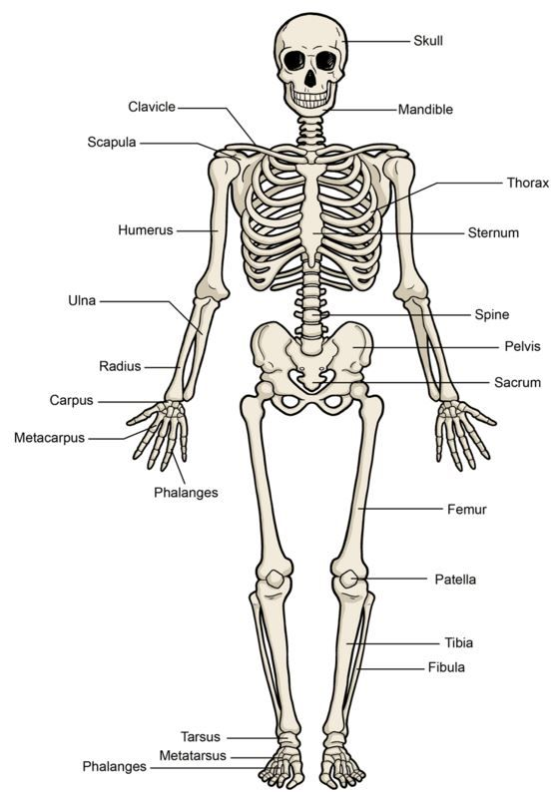
HUMAN SKULL IMAGE

